|  |  |  |  |  |  |  |
| --- | --- | --- | --- | --- | --- | --- |
| Algorithm | H5N1 | ADEA | dBA | PSO [6] | GA [3] | GA [8] |
| x1 | 3.05649 | 3.05770 | 3.04668 | 3.00000 | 3.00000 | 3.00000 |
| x2 | 61.12975 | 61.15460 | 60.93361 | 60.00000 | 60.00000 | 60.00000 |
| x3 | 2.81437 | 2.81330 | 2.81981 | 3.10000 | 3.10000 | 3.10000 |
| x4 | 56.28738 | 56.26530 | 56.39611 | 55.00000 | 55.00000 | 55.00000 |
| x5 | 2.52386 | 2.52360 | 2.52973 | 2.60000 | 2.60000 | 2.60000 |
| x6 | 50.47711 | 50.47170 | 50.59009 | 50.00000 | 50.00000 | 50.00000 |
| x7 | 2.20457 | 2.20460 | 2.20516 | 2.28866 | 2.28370 | 2.30820 |
| x8 | 44.09142 | 44.09111 | 44.10232 | 45.61715 | 45.55070 | 45.04880 |
| x9 | 1.74976 | 1.74980 | 1.74976 | 1.74982 | 1.75320 | 1.81180 |
| x10 | 34.99509 | 34.99510 | 34.99514 | 34.99622 | 35.06310 | 34.46260 |
| g1 | -0.00333 | -0.31175 | -0.00328 | -1.38360 | -81.60450 | -58.32610 |
| g2 | -0.29405 | -0.27259 | -10.90000 | -1358.60000 | -1337.40000 | -1191.10000 |
| g3 | -4.48655 | -0.06160 | -99.20000 | -153.84620 | -153.84620 | -153.84620 |
| g4 | -542.07829 | -526.39000 | -620.00000 | -1203.40000 | -1203.40000 | -1203.40000 |
| g5 | -867.02566 | -882.89000 | -740.00000 | -111.11110 | -111.11110 | -111.11110 |
| g6 | 0.00000 | -0.00001 | 0.00000 | 0.00000 | 0.00000 | 0.00990 |
| g7 | -0.00001 | 0.00019 | -0.00003 | 0.00000 | 0.00000 | 0.00000 |
| g8 | 0.00000 | -0.00025 | -0.00001 | -2.25810 | -2.25810 | -2.25810 |
| g9 | -0.00001 | -0.00012 | -0.00442 | -0.76920 | -0.76920 | -0.76920 |
| g10 | 0.00000 | -0.00041 | -0.00086 | -0.00007 | -0.05400 | -0.48310 |
| g11 | -0.00010 | -0.00051 | -0.00002 | -0.00013 | -0.05400 | -0.97880 |
| f(x) | 63108.87218 | 63109.16300 | 63113.61000 | 64578.37434 | 64599.65000 | 64691.98000 |

* indicates constraint value less than or equal to 1*10–4 (1E 4) and considered as zero (0).

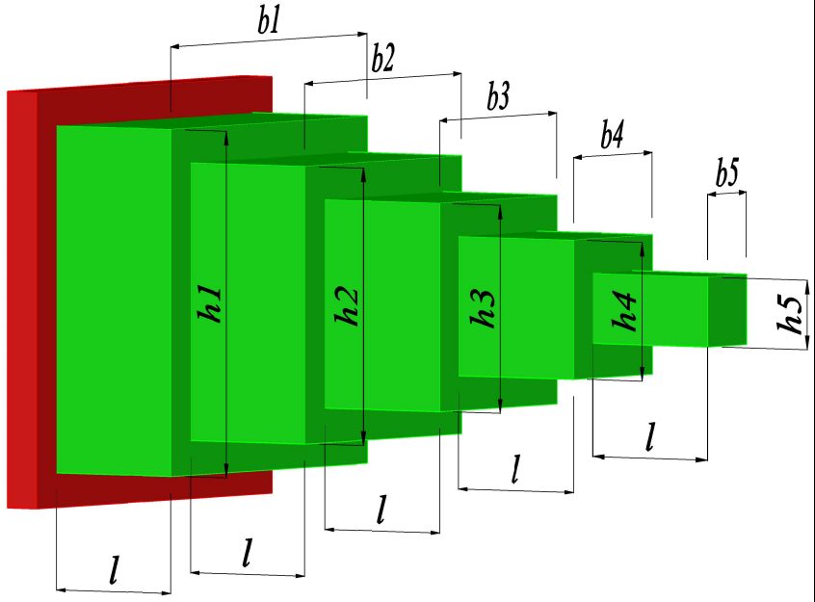

|  |  |  |  |  |  |  |  |  |
| --- | --- | --- | --- | --- | --- | --- | --- | --- |
| Optimum  Variables | Algorithm | | | | | | | |
| H5N1 | ADEA[1] | dBA [2] | PSGA [3] | SR[3] | GA [4] | GA [5] | BA [2] |
| $$x_{1}$$ | 3.05649 | 3.05770 | 3.04668 | 3.00000 | 3.10321 | 3.00000 | 3.00000 | 3.43593 |
| $$x_{2}$$ | 61.12975 | 61.15460 | 60.93361 | 60.00000 | 60.29433 | 60.00000 | 60.00000 | 56.98366 |
| $$x_{3}$$ | 2.81437 | 2.81330 | 2.81981 | 3.10000 | 2.79583 | 3.10000 | 3.10000 | 3.01897 |
| $$x_{4}$$ | 56.28738 | 56.26530 | 56.39611 | 55.00000 | 55.87571 | 55.00000 | 55.00000 | 54.81524 |
| $$x_{5}$$ | 2.52386 | 2.52360 | 2.52973 | 2.60000 | 2.56392 | 2.60000 | 2.60000 | 2.79102 |
| $$x_{6}$$ | 50.47711 | 50.47170 | 50.59009 | 50.00000 | 51.26774 | 50.00000 | 50.00000 | 51.81262 |
| $$x_{7}$$ | 2.20457 | 2.20460 | 2.20516 | 2.28866 | 2.24726 | 2.28370 | 2.30820 | 4.55338 |
| $$x_{8}$$ | 44.09142 | 44.09111 | 44.10232 | 45.61715 | 44.13850 | 45.55070 | 45.04880 | 36.22565 |
| $$x_{9}$$ | 1.74976 | 1.74980 | 1.74976 | 1.74982 | 1.79172 | 1.75320 | 1.81180 | 1.71773 |
| $$x_{10}$$ | 34.99509 | 34.99510 | 34.99514 | 34.99622 | 34.80139 | 35.06310 | 34.46260 | 35.32845 |
| $$g_{1}$$ | -0.00333 | -0.31175 | -0.00328 | -1.38360 | -175.00000 | -81.60450 | -58.32610 | -6.79000 |
| $$g_{2}$$ | -0.29405 | -0.27259 | -10.90000 | -1358.60000 | -295.00000 | -1337.40000 | -1191.10000 | -3960.00000 |
| $$g_{3}$$ | -4.48655 | -0.06160 | -99.20000 | -153.84620 | -645.00000 | -153.84620 | -153.84620 | -1990.00000 |
| $$g_{4}$$ | -542.07829 | -526.39000 | -620.00000 | -1203.40000 | -252.00000 | -1203.40000 | -1203.40000 | -771.00000 |
| $$g_{5}$$ | -867.02566 | -882.89000 | -740.00000 | -111.11110 | -704.00000 | -111.11110 | -111.11110 | -555.00000 |
| $$g_{6}$$ | 0.00000 | -0.00001 | 0.00000 | 0.00000 | 0.00000 | 0.00000 | 0.00990 | -0.05160 |
| $$g_{7}$$ | -0.00001 | 0.00019 | -0.00003 | 0.00000 | -1.77000 | 0.00000 | 0.00000 | -11.70000 |
| $$g_{8}$$ | 0.00000 | -0.00025 | -0.00001 | -2.25810 | -0.04080 | -2.25810 | -2.25810 | -5.56000 |
| $$g_{9}$$ | -0.00001 | -0.00012 | -0.00442 | -0.76920 | -0.01060 | -0.76920 | -0.76920 | -4.01000 |
| $$g_{10}$$ | 0.00000 | -0.00041 | -0.00086 | -0.00007 | -0.80700 | -0.05400 | -0.48310 | -54.80000 |
| $$g_{11}$$ | -0.00010 | -0.00051 | -0.00002 | -0.00013 | -1.03000 | -0.05400 | -0.97880 | 0.97400 |
| $$f\left(x\right)$$ | 63108.87218 | 63109.16300 | 63113.61000 | 64578.37434 | 63631.55000 | 64599.65000 | 64691.98000 | 74125.97000 |